SARDAR VALLABHBHAI NATIONAL INSTITUTE OF TECHNOLOGY, SURAT
DEPARTMENT OF CIVIL ENGINEERING
Computational Hydraulic Laboratory
TThe Computational Hydraulic Laboratory is developed under the Centre of Excellence on “Water Resources and Flood Management” in the Department of Civil Engineering. 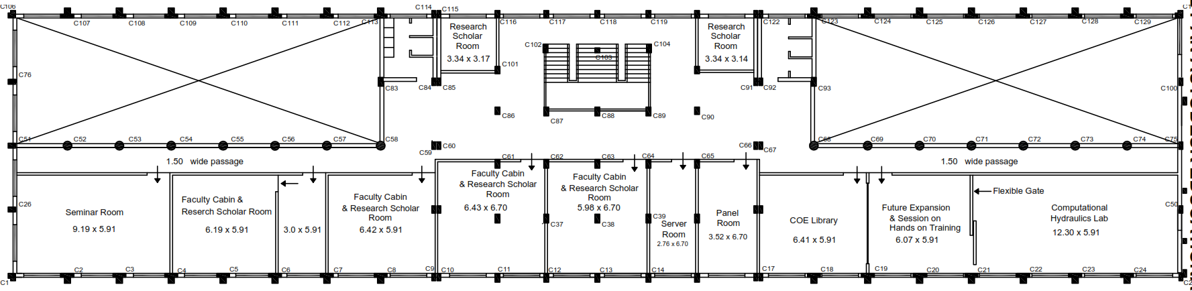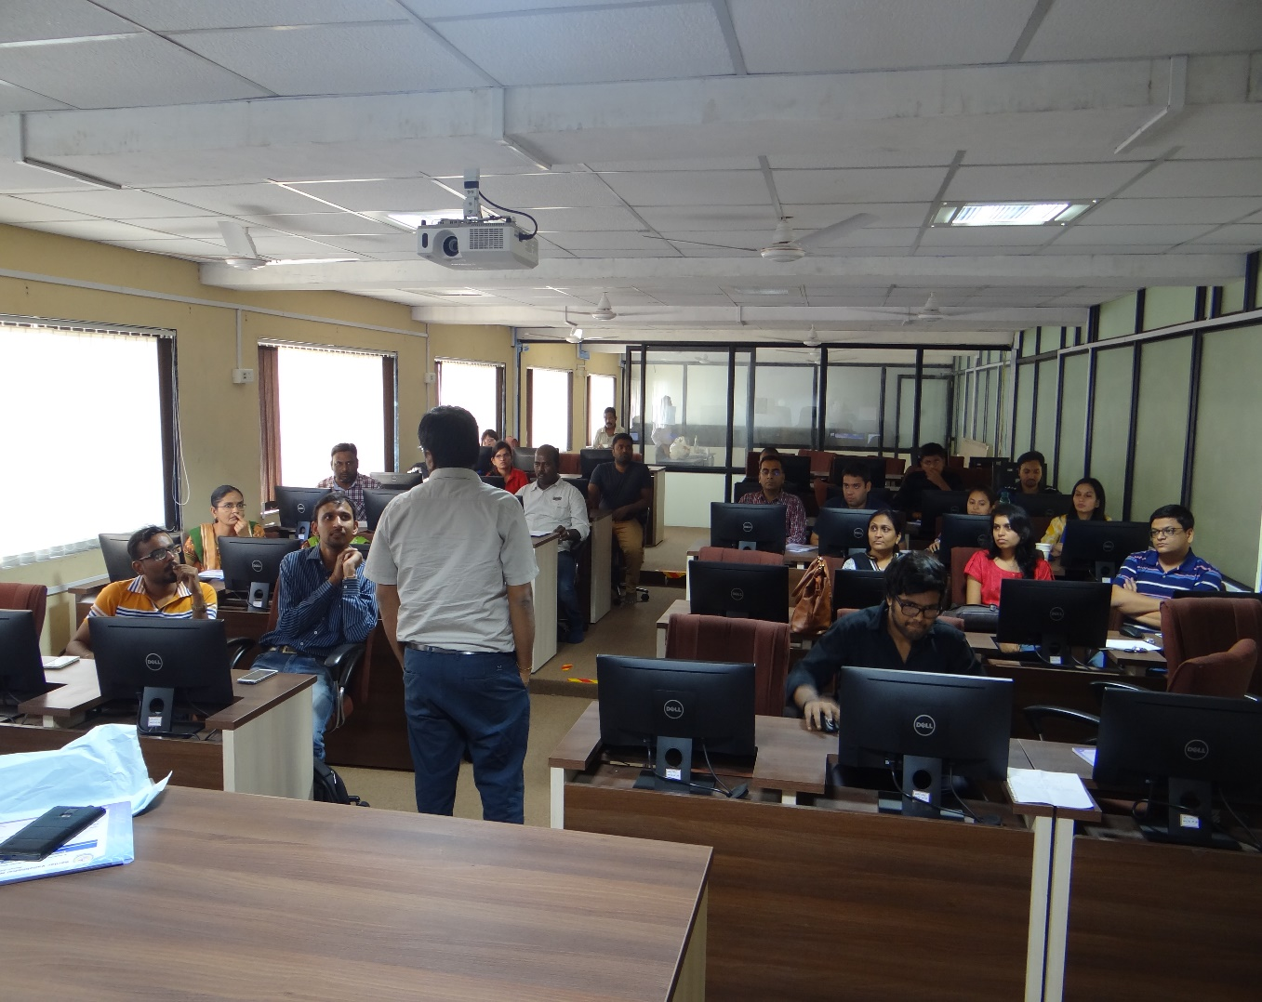
Following Softwares are available in the said Laboratory:
Sr No. | Name of Equipment/ Software's
1 | Desktop PCs (45 Nos)
2 | MIKE 11
3 | MIKE FLOOD
4 | MIKE 21 FM
5 | MIKE HYRDO BASIN
6 | MIKE SHE
7 | GMS
8 | ESRI ArcGIS 10.6
9 | ERDAS IMAGINE
10 | Bentley Water Gem
11 | Bentley Storm CAD
12 | Bentley Sewer Gem
13 | Bentley Hammer
14 | Auto CAD
15 | Statistica
16 | ANSYS
17 | MATLAB
18 | HEC-RAS
19 | HEC-HMS
20 | RiverCAD Professional
21 | HEC-2
22 | Origin Lab Pro V 2021b
23 | MIKE 21C

Following computation laboratory work is carried out in this laboratory:
- Analysis of steady state water surface profile using HEC-RAS.
- Analysis of unsteady state flood wave using HEC-RAS.
- Hydrologic modelling of catchment using HEC-HMS.
- Integration of hydrologic (HEC-HMS) and hydraulic models (HEC-RAS).
- Water Distribution network analysis using LOOP.
- Water distribution network analysis using Water GEMs.
- Water hammer analysis using Bentley Hammer.
- Reservoir optimization through linear programming solution using LINGO.

Apart from above laboratory work, UG, PG and PhD students are carried out their seminar, dissertation and doctoral thesis work using the resources of this laboratory. The CHL is also utilized for the consultancy purposes.

